CARbon Airborne Flux Experiment – CMS 2017

CARAFE-CMS2017 Flight Reports

CARAFE Science Team

May, 2017

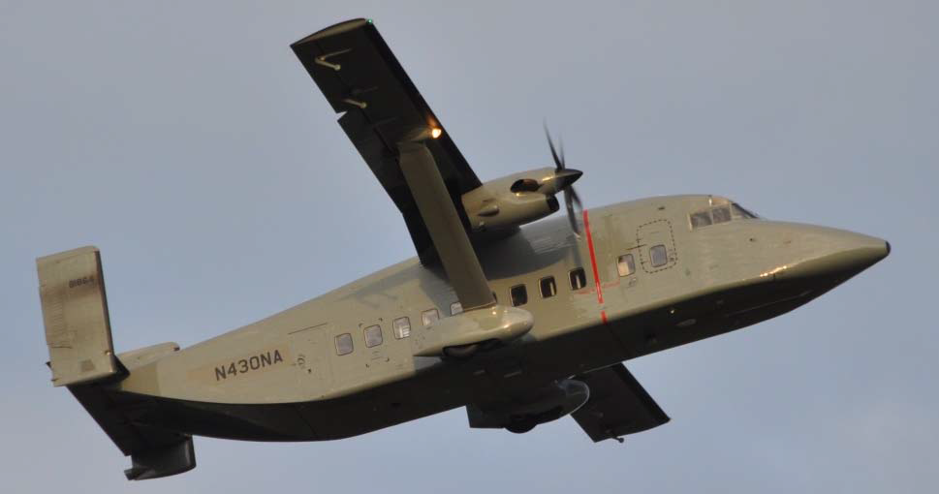

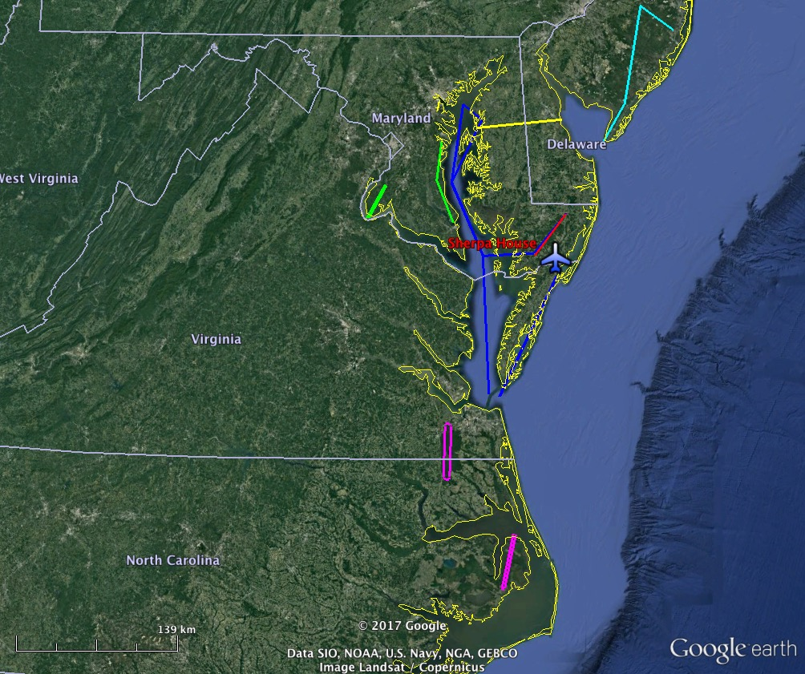
Date |  | Destination
3 May 2017 | Test Flight | Pocomoke Forest
4 May 2017 | Science Flt #1 | DelMarVa Agricultural
8 May 2017 | Science Flt #2 | Pocomoke Diurnal
9 May 2017 | Science Flt #3 | NJ Pine Barrens
10 May 2017 | Science Flt #4 | MD Tall Trees
15 May 2017 | Science Flt #5 | Alligator River, NC
16 May 2017 | Science Flt #6 | Dismal Swamp, Chesapeake Bay
18 May 2017 | Science Flt #7 | DelMarVa Ag Flux 2
19 May 2017 | Science Flt #8 | Pocomoke N2O Flux
26 May 2017 | Science Flt #9 | Alligator River, NC 2

CARAFE-CMS2017 Science Flight Report
2017-05-03
Test Flight #1
Pilots: R. Rogers, A. Barringer
Science Crew: R. Kawa, G. Wolfe, S. Pusede, J. Digangi, L. Thornhill, R. Hannun
Reporting: R. Kawa
Objectives: Verify instrument systems performance. Test modifications to payload since 2016 flights. Perform air motion calibration maneuvers. Characterize variations of mean fields and fluxes for GHGs (CO2, CH4, N2O), CO, water, and heat at different altitudes over relatively uniform forested region.
Summary:
Flight from WFF headed south and climbed to 6500 ft. Set of air motion calibration maneuvers (speed variations, yaw, pitch) was performed at 6500 ft. Flew back to N and did spiral descent over Pocomoke SW. Flux legs over Pocomoke Forest were flown back and forth in PBL at 1000 and 500 ft. Vertical profile to7500 ft followed with additional set of maneuvers. Flight duration 2.5 hours.

Instrument systems and flight procedures performed well. Speed maneuvers at 6500 ft and 7500 ft were in generally smooth air, although still within haze layer that appeared to top out just above our flight level (see sonde profiles). Winds in the BL were strong, e.g., 30 kts and air was very turbulent. Mostly clear with a few distant, scattered mid-level clouds and higher thin cover. Forest areas were bright green. Fields looked to be mostly in early stages of growth.

Rawinsonde special sounding at 18Z flown from WFF as well as an ozonesonde at approx. noon.

Instruments:
LGR/Picarro/PAR – instruments performed normally. Re-engineered air supply pumps ran nice and cool.

N2O/CO ran successfully. Data showed significant variability, but N2O appeared to have an unexpected dependence on pressure altitude.

DLH – Got good data throughout. Found some minor issues but nothing serious.

SIS (formerly know as BFVNI) – Mixed results from the test flight. Micasense was fine and got good data. The Nikkon camera lens cap was on. That issue is fixed and the Nikkon expected to work thereafter. The FLIR got data, but a licensing issue was encountered on following day (license expired May 4?). Working on resolution, but unsure of timeline. This is not a showstopper.

TAMMS – Good data throughout. Cal maneuvers appear successful. Applanix data looks normal. Redesigned air motion sensors seemed to work well.

NASDAT – Data recorded properly.

NSRC Server – Operational but most devices could not connect to wifi. No plotting capability yet; just limited chat.

Seamless transition from ground to aircraft, and aircraft to ground power.

Event Times (UT, approximate):
18:38 POS-AV logging start
18:50 Power transition to a/c
19:00:10 Takeoff
19:00 to 19:09 Climb to 6500 ft
19:11 to 19:25 Speed variations 120, 130, 140, 150, 160 kts at 6500 ft
19:26 Yaw maneuvers
19:30 Pitch maneuvers
19:35 to 19:46
19:46 to 20:03 Spiral descent to Pocomoke SW waypoint
20:05 to 20:43 Flux legs at 1000, 500, 500, 1000 ft
20:43 to 20:52 Profile to 7500 ft heading S
20:52 to 20:05 Speed variations at 7500
21:05 Yaw maneuvers
21:10 Pitch maneuver heading back N
21:27 Landing
17:30 Switch to ground power
21:45 POS-AV, SIS, NASDAT off
21:48 NASDAT on
21:50 NASDAT off
CARAFE-CMS2017 Science Flight Report

2017-05-04
Science Flight #1 Ag Flux
Pilots: R. Rogers, A. Barringer
Science Crew: R. Kawa, G. Wolfe, S. Pusede, G. Diskin
Reporting: R. Kawa

Objectives: Obtain GHG, water, and heat fluxes over relatively flat, extensive agricultural region across northern DelMarVa Peninsula. Characterize variations of surface flux with surface type and condition. Compare airborne flux distributions with those from flux towers at USDA Choptank and U DE St. Jones Reserve. Look for variability in N2O associated with different crop management, e.g., fertilization, as well as CO variability. Re-sample over Chester River, which showed high CH4 emissions in Sept flight.

Note that if all goes well, we will revisit this track later in the mission when things are warmer.

http://ameriflux-data.lbl.gov:8080/SitePages/siteInfo.aspx?US-StJ
http://www.ars.usda.gov/research/projects/projects.htm?accn_no=425859

Summary:
Flight started with climb out of KWAL and ferry N at ~1000’ toward Choptank point. Ascent profile to 5500’ was performed approaching Choptank with descent to 1000’ along line W toward Eastern Neck Island just W of Chester River. A leg E to Delaware Bay past Choptank and St. Jones Preserve towers was done at 1000’ followed by 5 legs back and forth at ~500’ and a final leg E at 1000’. Profile from 500’ to 6600’ was done along line back to Choptank followed by turn S and descent to 500’ for ferry to Pocomoke NE. A pair of legs across Pocomoke at 500’ was followed by a final leg, Pocomoke NE to SW, at 1000’ and return to base. Flight duration about 4 hours.

Weather was decent for measuring turbulent fluxes from/to the surface. Sky started out mostly clear and sunny with a few scattered high clouds and haze with top above FL10. Clouds thickened throughout the day and final legs were overcast. Winds were strong and turbulence good throughout boundary layer, which appeared to top at about 3300’. Surface was a mosaic of fields, woods, and small settlements. Fields were in various early stages of growth from freshly tilled to low green cover. Forests were bright. Marshland near St Jones looked relatively brown and dormant. We flew right through a small slash fire smoke plume on S end of 500’ Pocomoke leg.

Instrument systems and flight procedures performed smoothly. There did not seem to be a positive CH4 gradient over the Chester River this time. Variability in N2O was low, at least to preliminary look. Some regional gradients in CO, CO2, and H2O. CH4 enhancement seen just east of Choptank on some legs – local source?

Rawinsonde special sounding at 18Z flown from WFF.

Instruments:
LGR/Picarro/PAR – instruments performed normally. Pumps ran cool; cabin was cool throughout.

N2O/CO ran successfully. N2O continues to show an unexpected dependence on pressure altitude, perhaps somewhat correlated with other tracers. In flight cal would be nice.

DLH – Got good data throughout.

SIS (formerly know as BFVNI) – Had a last minute switch out of FLIR computer to dispel problem with licensing and new software. All systems worked well: Nikon, Micasense, and FLIR.

TAMMS – Good data throughout. Applanix data looks normal. Redesigned air motion sensors seemed to work well.

NASDAT – Data recorded properly.

NSRC Server – Operational but wifi not turned on pending configuration update.

Seamless transition from ground to aircraft, and aircraft to ground power.

Event Times (UT approximate):
14:30 POS-AV logging start
14:59 Engines on
15:01 Power transition
15:12 Takeoff
15:14 to 15:32 Transit toward Choptank
15:32 to 15:38 Ascent profile near Choptank
15:38 to 15:47 Descent to Chester River
15:47 to 17:50 Flux legs at 1000, 500 x 5, 1000’
17:54 to 18:04 Slant ascent 500 to 6500 ft over track
18:04 Descend to 500 ft
18:12 – 18:25 Transit to Pocomoke NE
18:25 – 18:56 Pocomoke legs at 2x500, 1000’
18:56 Transit to WFF
19:03:30 Landing
19:07 Transition to external power, uninterrupted
19:18 POS-AV stop logging
19:20 POS-AV, SIS, NASDAT off

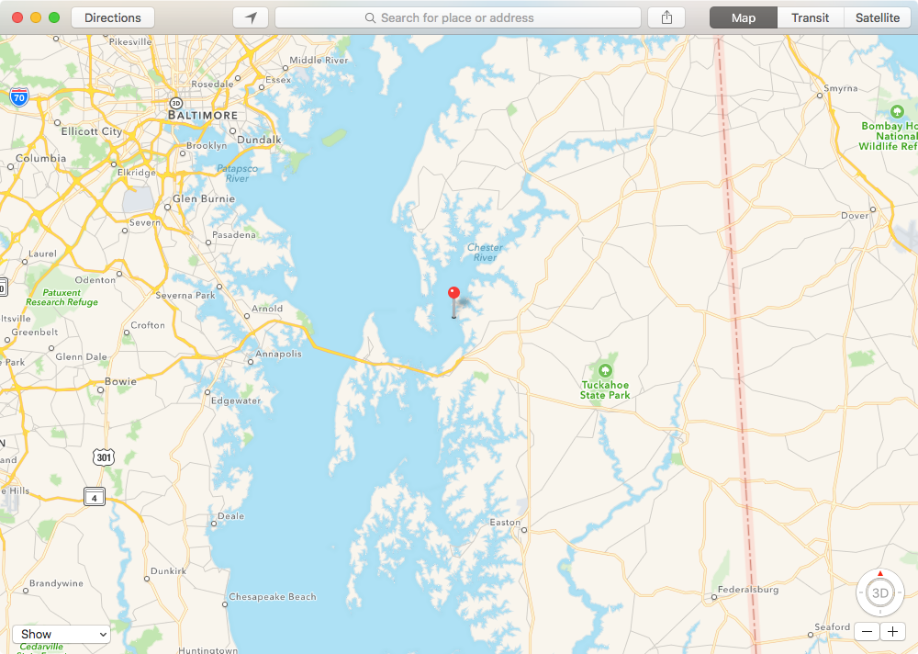
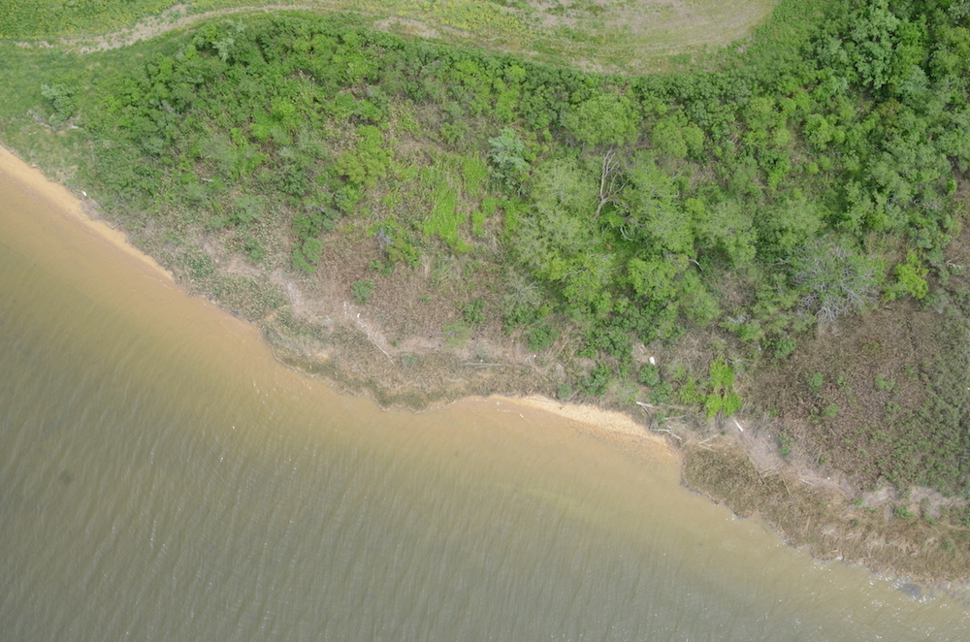
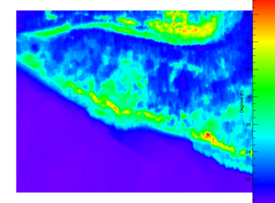
Image location, Nikon color, and FLIR images courtesy of Jim Yungel.

CARAFE-CMS2017 Science Flight Report
2017-05-08
Science Flight #2 Pokomoke Forest Diurnal
Pilots: M. Russell, A. Barringer
Science Crew: R. Kawa, T. Hanisco, G. Diskin (all); S. Kirby, S. Pusede, R. Hannun (morning)
Reporting: R. Kawa

Objectives: Measure GHG, water, and heat fluxes over Pocomoke forest over the course of the day to test changes of fluxes in response to varying solar illumination. Characterize variations of surface flux as well as mean fields including N2O and CO across the landscape. Enable extrapolation of regional NEE flux versus PAR to zero sunlight to estimate respiration.

Summary:
This was a two-sortie flight in the morning and afternoon with a 1.5 h refueling break near local noon. We basically flew the SW-NE track across the Pocomoke Forest all day. It started with a profile up to 4500 feet and spiral down to 1st waypoint at Pocomoke SW. Boundary layer top at about 3,400 feet. We did 3 legs at 500’, followed by 1 leg at 1000’ and 3 more legs at 500’. A climb to 6300’ feet over the line from Pocomoke NE led to ferry back to KWAL. No major decrease in H2O noted; nearly well-mixed. Total sortie duration about 2.5 hours.

Second sortie started with climb out to approx. 7300’ and spiral descent over Pocomoke SW. BL top appeared to be near top of profile. We then ran legs at 4x500’, 2x1000’, 4x500’, 2x1000’, and 5x500 for a total of 24 on the day. A final profile went along track from NE to 7500’, with apparent BL top at 7100’. Transit to KWAL completed long flight day. Total sortie duration about 3.7 h.

Everything worked well, and the plane was fairly cool. The surface winds were brisk from the W. Strong turbulence, likely both dynamical and thermal, settled down a bit later in the flight. There were a few scattered clouds, but almost completely clear early. A few widely scattered clouds casting occasional shadows late. Nearly ideal for tracking sun progression.

Rawinsonde special sounding at 18Z flown from WFF.

Instruments:
LGR flux/Picarro/PAR – instruments performed normally. Post flight, Glenn W. not satisfied with CH4 pressure control – too noisy.

N2O/CO ran successfully. N2O continues to show an unexpected dependence on pressure altitude.

DLH – Minor problem corrupted first profile; good data after that.

SIS – Visible, FLIR, and multispectral (Micasense) cameras acquired images normally after a brief GPS acquisition scramble during warm-up.

TAMMS – Good data throughout. Applanix data looks normal, 13% disk used.

NASDAT – Data recorded properly.

NSRC Server – Operational with wifi, maps, some data, and chat.

Event Times (UT approximate):
14:00 POS-AV logging restart
14:18 Engine start, power switch
14:26 Taxi
14:32 Takeoff 1
14:34 to 14:47 Profile to 4500 and descent
14:47 to 16:07 Flux legs at 500 and 1000 ft
16:10 Ascent to 6300 ft along track
16:23 Landing 1
16:27 Engines off, power switch

16:27 to 17:45 Fueling, lunch break, instrument power on throughout

17:52 Engine start, power switch
17:58 Taxi
18:02 Takeoff 2
18:05 to 18:23 Profile to 7500 and descent
18:23 to 21:21 Flux legs at 500 and 1000 ft
21:23 Ascent to 7500 ft along track
21:40 Landing 2
21:45 Engines off, power switch

CARAFE-CMS2017 Science Flight Report
2017-05-09
Science Flight #3 NJ Pine Barrens
Pilots: A. Barringer, M. Russell
Science Crew: R. Kawa, R. Hannun, G. Diskin, L. Barry
Reporting: R. Kawa

Objectives: Measure GHG, water, and heat fluxes over the New Jersey Pine Barrens. Characterize variations of surface flux with forest type, disturbance state, and surface conditions. Characterize gradients in mean tracer fields and correspondence with local conditions. Compare airborne flux distributions with those from Ameriflux tower measurements at Silas Little and Cedar Bridge sites.
http://ameriflux-data.lbl.gov:8080/SitePages/siteInfo.aspx?US-Slt
http://ameriflux-data.lbl.gov:8080/SitePages/siteInfo.aspx?US-Ced

Summary:
Outbound transit took place at 3500’ with spiral descent to NJ-Mid waypoint, BL top about 2500’. Flux legs were performed in an inverted ‘7’ shape across the Pine Barrens at 1000’x1.5, and 500’x4. Legs passed nearly overhead the Cedar Bridge site and near to the Silas Little sites. A final profile up to 6600 ft was performed along track from NJ-N to NJ-Mid. Return transit flight took place at 4500’. Flight duration about 4 hours.

Weather was good for measuring turbulent fluxes from/to the surface. Sky was mostly clear and bright over flux tracks with moderate winds and modest turbulence at both altitudes. A few scattered Cu and haze in the distance. Boundary layer height near 2500 ft before and after legs. Surface was mostly a wide area of nearly unbroken woods, with some settlements and roads near the middle of the N-S track. Not much agriculture. Noted generally moist ground conditions with some flooded ag fields as well as areas of dead or perhaps late-leafing trees. Comfortable temperatures inside and outside cabin throughout flight at low altitudes.

We had repeated encounters with landfill CH4 near the S end of the flight legs (NJ Mid waypoint), especially when east of landfill site. (https://ghgdata.epa.gov/ghgp/service/facilityDetail/2014?id=1004200&ds=E&et=undefined&popup=true). No CH4 enhancement coming off extensive marsh grass region along Egg Harbor River. Some CH4, CO2, CO enhancement and N2O decrease regionally, generally from South to North point. Noted very sharp increase in H2O over ocean east of NJ-E waypoint and in turns there. Note also tracer increases likely due to water vapor uncorrection.

Instrument systems and flight procedures performed well. Fuel reserve was a concern so last N-S leg was not done at low altitude. Flight was shorter than previous to this area yet seemed to use more fuel for similar tracks.

Rawinsonde special sounding at 18Z flown from WFF.

Instruments:
LGR/Picarro/PAR – LGR instruments and PAR sensor operated normally. CH4 pressure channel still looks noisy on low legs. Picarro lost lock on H2O line for about last 1/3 of flight.

N2O/CO ran successfully. N2O continues to show an unexpected dependence on pressure altitude.

DLH – Got good data throughout.

SIS – Visible, FLIR, and multispectral (Micasense) cameras acquired images normally.

TAMMS – Good data throughout. Applanix data looks normal, 13% disk used.

NASDAT – Data recorded properly. Problem with file naming in post flight shut down, but recoverable.

NSRC Server – Operational with wifi, maps, some data, and chat. Dewpoint hygrometer operational.

Event Times (UT approximate):
14:49 Engine start
14:50 Power switch
14:55 Taxi
15:01:40 Takeoff
15:11 Ascend to 3500 en route to Cape May
15:34 Spiral descent to 1000 ft near NJ mid
15:36 to 18:11 Flux legs at 1000 (1), 500 (4), and 1000 (0.5) ft
18:20 Ascent to 5000 ft and transit to Wallops
19:05:00 Landing
19:14 Power switch, engines off
19:24 POS-AV stop logging, NASDAT off-on-off

CARAFE-CMS2017 Science Flight Report
2017-05-10
Science Flight #4 MD Tall Trees
Pilots: M. Russell, A. Barringer
Science Crew: R. Kawa, T. Hanisco, L. Barry, G. Diskin
Reporting: R. Kawa

Objectives: Measure GHG, water, and heat fluxes over tallest trees in MD with large fractional forest coverage according to UMD lidar surveys. Characterize variations of mean fields and surface flux with forest height, type, and surface conditions. Prince Frederick legs also test flux calculations in slightly more complex terrain. Compare airborne flux distributions with those from surface measurements over tidal wetlands at Smithsonian Environmental Research Center. Prior flight over Charles Co. showed some of the largest CO2 fluxes encountered in Sept.

http://www.serc.si.edu/gcrew/index.aspx

Summary:
Flight from KWAL climbed out to about 3500’ then descended to 2500’ for ferry to near Easton and then transit W across the Bay to PrinceFredN waypoint at 1000’. We flew the relatively long back and forth legs over Prince Frederick forest area at 1000 and 500’ (2) in PBL. Passed over SERC on N end. Surface was mix of mostly forest, fields, and small settlements; more solid forest to S end. Modestly rolling terrain.

Transit over to adjusted CharlesNE point was at 1000’; this should also be good flux territory. Did one flux run S at 1000 then dropped to 500’ for multiple (6) 5-6 minutes racetrack legs over forest on 3 tracks spaced 1-mi apart, and one final leg at 1000’. Thick solid forest with occasional dwellings. Saw a small fire on west-most leg. Varying canopy height and structure, mostly bright deciduous, but a few weary-looking pine stands. Turns at S end over Potomac appeared to have enhanced CO2 and maybe CH4 - WV correction? We ran back to PrinceFredS again most at 500’ and did one last flux leg up PrinceFred at 500 ft. We then climbed to about 7500’ heading E over Bay and Kent Island. The ferry abck S descended to 1000’ for some CH4 flow tests and return to base. Duration about 3.5 hours.

Sky was mostly clear with some high Ci and scattered Cu later in flight. Hazy sunshine over flux legs with distinct shadows. Not much wind. Decent turbulence at all altitudes below about 2500’. Scattered clouds with bases at about 6500 feet on return ferry. Boundary layer ~3000 feet had no distinct cap in H2O; some Co2 gradient. Possibly several layers. Everything worked well, and the plane was fairly cool.

Rawinsonde special sounding at 18Z flown from WFF.

Instruments:
LGR/Picarro/PAR – Picarro water channel did not look good: too flat. This is a previously seen problem for the aging instrument. LGR instruments and PAR sensor performed well. Tom H tried several in flight adjustments to CH4 pressure control.

N2O/CO ran successfully. N2O continues to show an unexpected dependence on pressure altitude.

DLH – Got good data throughout.

BFVNI – Visible, FLIR, and multispectral (Micasense) cameras apparently acquired images normally.

TAMMS – Good data throughout. Applanix data looks normal; disk at 26%

NASDAT – Data recorded normally. Shutdown and file rename done manually by Sean but no indication of problem.

NSRC Server – Operational with wifi, maps, parameter table, and chat. Dewpoint hygrometer operational.

Event Times (UT approximate):
14:42 Engine start
14:44 Power switch
14:50 Taxi
14:56 Takeoff
15:01 Ascend to 3500 en route N
15:19 Descend to 2600 ft
15:30 Descend to 1000 for ferry W
15:32 to 16:12 Flux legs at 1000 (1) and 500 (2) ft near Prince Frederick
16:14 Transit to Charles NE at 1000’
16:24 to 17:30 Flux legs at 1000 (2) and 500’ (6 w/offset) near Charles Co
17:32 Transit to Prince FredS at 500’
17:42-17:54 Flux leg to Prince Fred N at 500 ft
17:57 Transit E at 1500’
17:59 Ascend to 7800 enroute E
18:08 Descend to 1000 heading S
18:32:45 Landing
18:36 Power switch, Engines off
18:50 POS-AV stop logging
18:59 NASDAT off-on-off
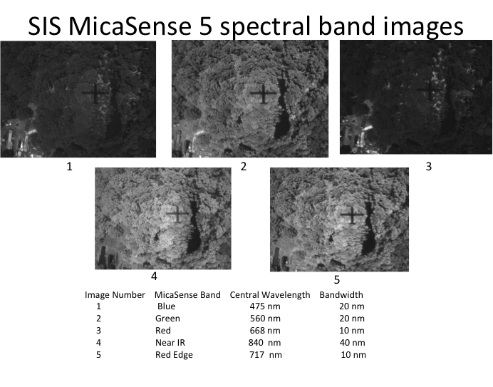
Sherpa looks so slender in its shadow. From Charles Co leg.
CARAFE-CMS2017 Science Flight Report
2017-05-15
Science Flight #5 Alligator River, NC Coastal Forest
Pilots: R. Rogers, A. Barringer
Science Crew: R. Kawa, P. Newman, T. Hanisco, L. Barry, G. Diskin, J. Nowak
Reporting: R. Kawa

Objectives: Measure GHG, water, and heat fluxes over coastal plain wetland forests in North Carolina at Alligator River National Wildlife Refuge. Characterize variations of mean mixing ratios and surface flux with forest type, inundation state, and surface conditions especially in search of CH4 flux. This site had by far the largest CH4 emissions of the Sept campaign. Compare airborne flux distributions with those from Ameriflux/NCSU tower measurements at Alligator River site. The latter is one of only a couple sites measuring CH4 flux within range.

http://ameriflux-data.lbl.gov:8080/SitePages/siteInfo.aspx?US-NC4

Summary:
Flight day began with a last minute change in objective. We were notified that Alligator River restricted area would not be available for the remainder of the week, but we could get in that afternoon. So we took it. Takeoff was delayed to 1300. Only 1 hour on station was guaranteed at Alligator.

Transit to Alligator ran direct at 7500 ft. Spiral descent performed into AlligatorN waypoint. A set of flux legs was flown N-S, offset E and W from mid-line by about 1.5 mi. at 1000 and 500(5) ft. Center track (S-N waypoints) passed nearly overhead the US-NC4 flux tower site. A profile to 6500 ft was performed after the legs over the northernmost end of the track near AlligatorN mostly over land. Full set of maneuvers was performed on return transit. Gradual descent into KWAL for instrument pressure cal. Flight duration about 4.1 hours.

Weather was very good for measuring turbulent fluxes from/to the surface. Sky was clear and bright over flux tracks throughout, with a thin haze near BL top. Boundary layer height started at about 3600 ft in decent mostly over water at Albemarle Sounde but was as high as 4500 ft in later profile at N end over land. All legs seemed to have good turbulence. Stiff winds from the NW.

Surface at Alligator River was a relatively sparser forest, more variable cover including some dead zones, and with generally more pine. This area was also very wet at surface including partially flooded farm fields. Dense understory visible in some places. Both trees and understory were bright green. Easternmost leg was mostly over lower, more boggy vegetation. No major features in GHGs. Generally cool temperatures inside and outside cabin throughout flight especially at higher altitudes.

Instrument systems and flight procedures performed normally. N2O instrument ran calibrations on ascent and descent at KWAL to try and characterize pressure dependence on signal.

Rawinsonde special sounding at 18Z flown from WFF.

Instruments:
LGR/Picarro/PAR – All ran normally. No sign of trouble for Picarro water. Perhaps cal.ini reset last week helped.

N2O/CO ran normally on low legs. Newly installed in-flight cal system was exercised on profiles to/from Wallops. Results pending.

DLH – Got good data throughout. Lee T. noted postflight that RH parameter (which is calculated from DLH) was missing from IWG1 files. This is recoverable.

BFVNI – Visible, FLIR, and multispectral (Micasense) cameras acquired images normally.

TAMMS – Good data throughout. Applanix data looks normal, 37% disk usage.

NASDAT – Data recorded properly except for the possible RH issue noted above.

Event Times (UT approximate):
16:46 Engine start
16:47 Power switch, dewpoint on
16:54 Taxi
16:59:20 Takeoff
17:04 Ascend to 7500 en route to VA Beach
17:41 Descend to 1000 ft near AlligatorN
17:51 - 18:44 Flux legs at 1000 and 500 (5) ft
18:44 – 18:52 Ascent to 6500 near AlligatorN
18:55 Transit at 7500”
19:01 Speed variation maneuvers at 120, 130, 140, 150 kts
19:10 Yaw maneuvers
19:21 Pitch maneuvers
19:27 Slow descent to KWAL
19:49:30 Landing
19:56 Power switch, engines off
20:08 POS-AV stop logging, NASDAT off-on-off

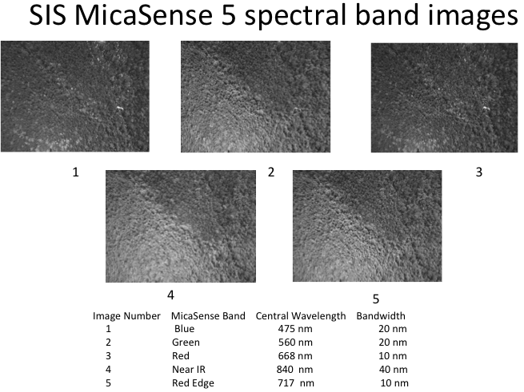

Flux tower US-NC4 at Alligator River Refuge and why NDVI works for vegetation. Images courtesy of Jim Yungel.

CARAFE-CMS2017 Science Flight Report
2017-05-16
Science Flight #6 Dismal Swamp and Chesapeake Bay
Pilots: A. Barringer, R. Rogers
Science Crew: R. Kawa, P. Newman, G. Wolfe, L. Barry, J. Nowak
Reporting: R. Kawa

Objectives: Measure GHG, water, and heat fluxes over coastal plain wetland forest in Virginia: Great Dismal Swamp. Characterize variations of mean mixing ratio and surface flux with forest type, inundation state, and surface conditions especially in search of CH4 flux. Examine seasonal change in flux from Sept sampling. The Great Dismal Swamp National Wildlife Refuge is the largest intact remnant of a vast habitat that once covered more than one million acres of southeastern Virginia and northeastern North Carolina.

In addition, measure flux and mixing ratio gradients along the Chesapeake Bay from South to North. Test hypothesis that CH4 flux depends on freshness of water, increasing going up Bay and river mouths. CO2 flux may also depend on gradients in nutrient loading in the water.

https://www2.usgs.gov/climate_landuse/lcs/great_dismal_swamp/GDS_project.asp

Summary:
Flight began with a climb to 5500’ and transit, with yaw maneuvers, to the Great Dismal Swamp near Virginia Beach, VA. A spiral descent ran down to DismalNW and a set of flux legs was flown N-S in racetrack shape separated by about 3 mi. at 1000 (2) and 500 (5) ft. Eastern legs passed over Lake Drummond. A profile to 5000 ft was performed after the legs along/above the track from the southernmost end.

The plane then flew a transit at 5500’ to a point north of waypoint Bay S and did a spiral descent to 500’. A long leg ran up the Chesapeake Bay at about 500 ft to near Tilghman Island and then to the NE over Kent Island, up the Chester River, and back west to the Bay east of Baltimore. The southbound leg ran down the Bay, over the Bridge, and near the shoreline to Fishing Creek, MD, and then straight south in mid-Bay toward BayS, all at 500’. From there, we climbed up to about 5000’ heading back east to KWAL and landing. Flight duration about 4. hours.

Weather was very good for measuring turbulent fluxes from/to the surface. Sky was mostly clear and bright over flux tracks throughout, somewhat hazy near BL top with scattered high clouds. Boundary layer height was at about 3000 ft over Dismal. All legs seemed to have good turbulence. Somewhat less turbulence over water including Lake D. Winds very light, W at 2 - 4 kts, lake smooth, 22 – 23 C.

Surface at Dismal was a wide area of nearly unbroken tall, thick forest, with a few fields toward the ends and some swampland near Lake Drummond. Mixed pine and hardwood forest, and intervening wetlands appeared very saturated. Interesting variability in CH4 and CO2 possibly associated with Lake and surrounding swamp relative to the woodland, although CH4 enhancements could be related to a landfill just N of the turn at the N end of the track (Tidewater Recycling?).
Water was very smooth at south end of Bay getting a bit choppy with time and to the N. Wind SW at 4 kts, 18.4 C going to 13 kts and 19.5 C. BL height at BayS about 3500’ with possible second layer near 700’. CH4 up by about 40 ppb in BL compared to free trop (beware WV correct). Light turbulence over Bay water. CH4 spike again seen near Poplar Island sludge fill. No apparent CH4 enhancement coming off extensive salt marsh grass region along final leg along shore. Big CO2 spike near Crapo, perhaps ship plume. BL on final climb at about 4000’ near coastline. Generally comfortable temperatures inside and outside cabin throughout flight at all altitudes.

Instrument systems and flight procedures performed well. We had a brief delay on taxi out for an avionics issue that was quickly resolved. N2O continued to run cal gas on some profiles and legs. A more extensive set of yaw maneuvers was performed on outbound transit at 5500’.

Rawinsonde special sounding at 18Z flown from WFF.

Instruments:
LGR/Picarro/PAR –LGR instruments and PAR sensor performed well. Glenn W. reports that CH4 pressure control problem is resolved. Vacuum pumps showed no signs of overheating on this warmest flight of the campaign.

N2O/CO ran normally on most legs. In-flight cal system was exercised on some legs and profiles. Results pending.

DLH – Got good data throughout. Had an output stream and display problem that prevented RH calculation in NASADAT, but all recoverable.

BFVNI – Visible, FLIR, and multispectral (Micasense) cameras acquired images normally.

TAMMS – Good data throughout. Applanix data looks normal.

NASDAT – Data recorded properly (except RH as noted above), however NASDAT file renaming on USB drive did not complete. This was resolved after flight with no apparent loss of data.

Event Times (UT approximate):
14:44 Engine start
14:46 Power switch
14:52 Taxi
15:08:40 Takeoff
15:11 Ascend to 5500 en route to SW
15:18 – 15:25 Yaw maneuvers
15:41 Descent spiral to 1000 ft near Dismal NW
15:46 - 16:48 Flux loops at 1000 and 500 ft
16:50 – 16:54 Ascent to 5000 ft along track to N
16:54 – 17:18 Transit to Bay points at 5500’
17:18 Descent spiral to 500’
17:24 – 17:48 Flux leg up Bay to Tilghman Island at 500’
17:48 – 17:57 Flux leg up to Chester River at 500’
17:57 – 18:03 Leg toward E Balto at 500’
18:04 – 18:45 Legs S along Bay at 500’
18:45 Turn left and ascend to 5000’ enroute to KWAL
19:02:55 Landing
19:08 Power switch, engines off
19:19 POS-AV stop logging, NASDAT off-on-off

CARAFE-CMS2017 Science Flight Report
2017-05-18, Thursday
Science Flight #7 Ag Flux across Delmarva N. Neck
Pilots: A. Barringer, R. Rogers
Science Crew: P. Newman, L. Barry, J. Nowak, R. Hannun, J. Barrick
Reporting: P. Newman

Objectives: Obtain GHG (including N2O), water, and heat fluxes over relatively flat, extensive agricultural region across the northern DelMarVa Peninsula. Characterize variations of surface flux with surface type and condition, particularly for N₂O. Compare airborne flux distributions with those from flux towers at USDA Choptank and U DE St. Jones Reserve.

For today, temperatures are considerably warmer (low 90s) than occurred on the flight of 5/4 (mid-60s).

http://ameriflux-data.lbl.gov:8080/SitePages/siteInfo.aspx?US-StJ
http://www.ars.usda.gov/research/projects/projects.htm?accn_no=425859

Summary:

A little hic-up at the start, since headsets were not working. Bill got on board and flipped the switch (atop DLH rack). Laura and Reem needed a computer restart for N2O. Aircraft interior was very hot before takeoff, but cooled significantly. Weather was pretty good, with high overhead cirrus. Takeoff was at 15:05 to the south, with good data reported by all immediately after takeoff at 15:10.

Turned and proceeded direct to Choptank Tower in the approximate center of our track. Did yaw maneuvers on way up at 1000’ with John Barrick discussing this from the back seat with Alan and Rich (completed 15:18). Continued northward while still ascending to 6500’. The boundary layer on this northbound route was ~2000’, but the profile was isothermal to about 3800’. We turned toward the Chester (E. waypoint) at ~15:35 while descending. The air was very hazy, as expected from the AQ forecast. Boundary layer was a 2000’ on this descent.

1) 1st track from ChesterE. St. Jones start at 15:42 at 1000’.
2) E. St. JonesChester start at 15:59 500’
3) ChesterE. St. Jones start at 16:17 at 500’, offset 1.5 nm N of track.
4) E. St. JonesChester start at 16:36 500’
Hit a little wake turbulence from a C-17 landing at Dover ~12:36
5) ChesterE. St. Jones start at 16:52 at 500’, offset 1.5 nm S of track.
Saw a couple of landfills along this ChesterE. St. Jones track: 1) near the western end, and 2) at about 17:00. My google search suggests that the 1st is RB Baker & Sons, 501 4-H Park Rd, Queenstown, MD 21658, while the 2nd is Mid-Shore II Regional Landfill, 11930 Holly Rd, Ridgely, MD 21660.
6) E. St. JonesChester start at 17:09 at min alt. (~400’)
7) ChesterE. St. Jones start at 17:25 at min alt. (~400’)
Saw a fire to the south of the track. I think we flew through this plume. ~17:26 (see photo).
8) E. St. JonesChester start at 17:41 at 500’.
9) ChesterE. St. Jones start at 17:58 at 500’.
10) E. St. JonesChester start at 18:15 at 1000’.
11) Climbing ascent from ChesterE. St. Jones start at 18:31

On the climbing ascent, we did not see a distinct boundary layer all of the way up to 7800’. Got about 2/3 of the way across this track, and then turned towards WFF. Cruised back to WFF at 7800’, and started descent at about 18:52. Boundary layer was at 2800’ on this descent.

Landed at about 19:05. Again, the naming of the files failed.

Rawinsonde special sounding at 18Z flown from WFF.

Instruments:

LGR/Picarro/PAR –LGR instruments and PAR sensor performed well. Reem and Laura reported good data. CH4 was run in slow (1-s) mode.

N2O/CO ran normally on most legs. N₂O was run in fast flux mode. In-flight cal system was exercised.

DLH – Got good data throughout. Display worked great.

BFVNI – Visible, FLIR, and multispectral (Micasense) cameras acquired images normally.

TAMMS – Good data throughout. Applanix good.

NASDAT – Data recorded properly, however NASDAT file renaming on USB drive did not complete. This was resolved after flight with no apparent loss of data.

Event Times (approximate UTC, -4 for EDT):
14:44 Engine start
14:49 Power switch
14:51 N₂O cal cylinder opened
14:54 Taxi
15:05 Takeoff
15:18 – 15:25 Yaw maneuvers
15:23 Ascend to 6500 en route to Choptank
15:33 At 6500’, starting descent, turning towards Chester (E. waypoint)
15:43 Starting first flux leg at 1000’
15:43 - 18:31 Flux loops at 1000’, 500’, and min alt.
18:31 Starting climb from 1000’ along flux track from Chester towards E. St. Jones
18:38 After reaching 7800’ (little evidence of boundary layer inversion) RTB
18:52 Began descent to WFF
19:05 Landed
19:09 Switch to external power

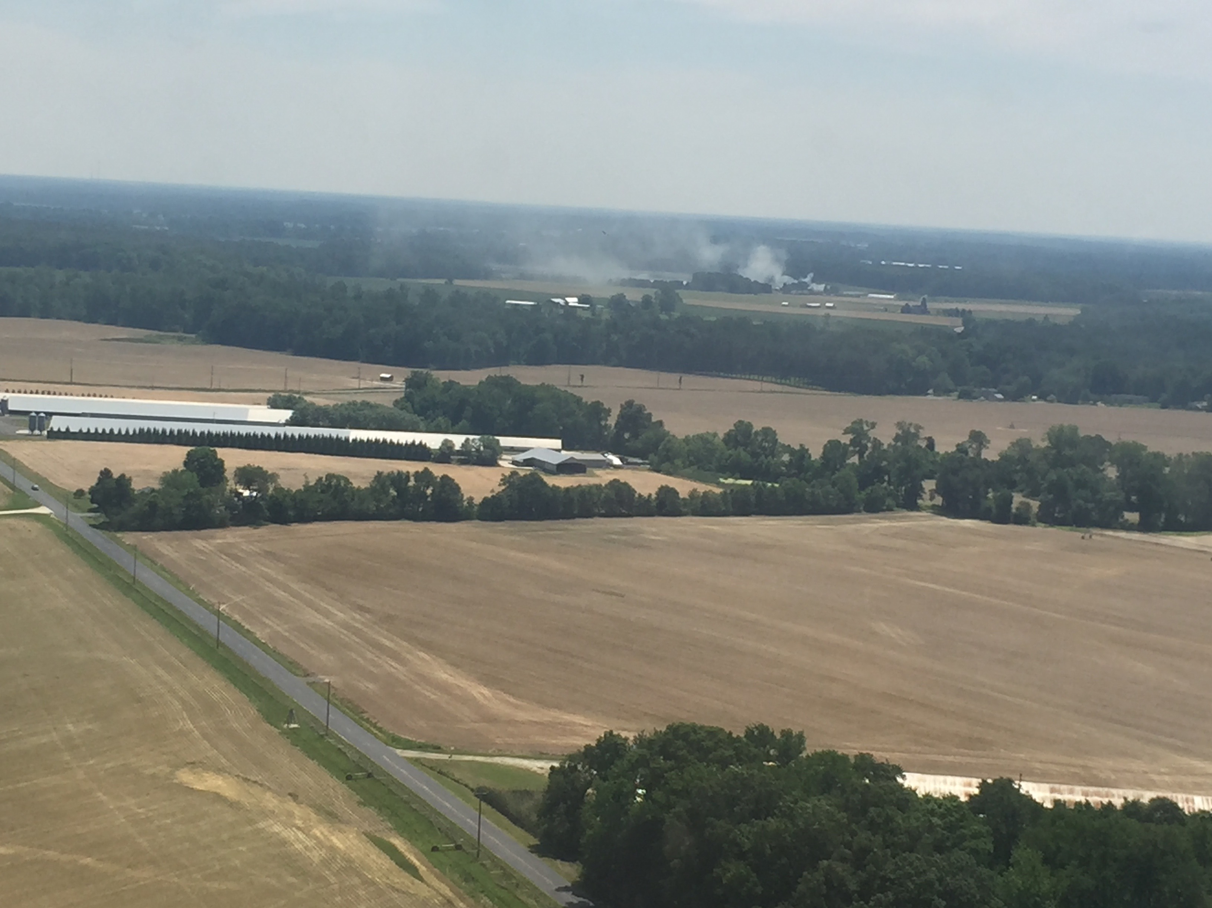
Photo from 5/18/2017 at ~17:26. Shows a fire with plume drifting N across Sherpa flight track from Chestertown to E. St. Jones waypoints. Approximately SW of Centreville, MD.
CARAFE-CMS2017 Science Flight Report
2017-05-19, Friday
Science Flight #8: Pocomoke N₂O flux flight
Pilots: A. Barringer, R. Rogers
Science Crew: P. Newman, L. Barry, J. Nowak, R. Hannun
Reporting: P. Newman

Objectives: Obtain GHG (including N₂O), water, and heat fluxes over the relatively uniform Pocomoke Forest track [Pocomoke Waypoint NE (38°23'28.85"N, 75°22'18.53"W) to Pocomoke Waypoint SW (38° 5'6.15"N, 75°40'19.52"W)]. Characterize variations of surface flux with surface type and condition, particularly for N₂O. For today, temperatures are considerably warmer (low 90s) than occurred on the flight of 5/4 (mid-60s). There was a high of 91˚F from the Wakefield, VA site at 2:04 PM.

http://ameriflux-data.lbl.gov:8080/SitePages/siteInfo.aspx?US-StJ
http://www.ars.usda.gov/research/projects/projects.htm?accn_no=425859

Summary:

Startup was pretty nominal. We advanced an hour from our normal takeoff time to 10AM EDT because of some possible Cb’s popping in the afternoon (as it turns out they didn’t pop up unital early evening). At takeoff, and throughout the day, the skies were clear, but somewhat hazy (see attached picture). At 10:08 we started our leg up the coastline about 3nm from the shore (see attached photo of Ocean City, MD).

The initial ascent to Pocomoke NE had a boundary layer at 1300’ (generally over the salt marshes as I recall). We arrived over Pocomoke NE and did a spiral descent and found the boundary layer at 2100’. We did a fairly long series of legs here with a couple of offset legs as well as min-alt. legs. There was a clear gradient in T and constituents on these legs with warmer Ts at NE point.

We started a spiral ascent at Pocomoke NE to end the day at 16:57, but had to do a fast descent to avoid traffic going into Salisbury. At 17:04 we re-started our spiral ascent and found the boundary at 2400’ over Pocomoke NE. After reaching 6500’, we turned toward Pocomoke SW and started an “in-line” descent. Here we found the boundary later at about 2700-2800’ in the middle of the track.

Rawinsonde special sounding at 18Z flown from WFF.

Instruments:

LGR/Picarro/PAR –LGR instruments and PAR sensor performed well. CH4/H2O ran in slow (1-s) mode. Reem and Laura reported good data. Post-flight noted that Picarro pressure control and, hence data, was intermittent.

N2O/CO ran normally on most legs. Instrument ran in fast flux mode.

DLH – Got good data throughout. Display worked great.

BFVNI – Visible, FLIR, and multispectral (Micasense) cameras acquired images normally.

TAMMS – Good data throughout. Applanix good.

NASDAT – Data recorded properly, however NASDAT file renaming on USB drive did not complete. This was resolved after flight with no apparent loss of data.

Event Times (approximate UTC, -4 for EDT):
1349 Engine Start
1352 Transfer ground to aircraft power
1356 Taxi
1404 Takeoff
1409 Leg 01: Began ocean leg, ~ 3nm from shore.
1424 Leg 02: Turned toward Pocomoke NE and began ascent
1437 Began spiral descent over Pocomoke NE.
1448 Leg 03: began NE SW @ 1000’
1500 Leg 04: began SW NE @ 500’
1511 Leg 05: began NE SW @ 1000’
1522 Leg 06: began SW NE @ 500’, offset NW
1532 Leg 07: began NE SW @ 500’, offset SE
1542 Leg 08: began SW NE @ 500’
1553 Leg 09: began NE SW @ 500’
1604 Leg 10: began SW NE @ min alt. ~380’
1615 Leg 11: began NE SW @ min alt. ~380’
A couple of bird misses on this leg.
1625 Leg 12: began SW NE @ 500’
1636 Leg 13: began NE SW @ 500’
1647 Leg 14: began SW NE @ 1000’
1655 Began spiral ascent over NE
1711 Began descent NE SW
1721 RTB
1729 Landed WFF
1732 Stop Taxi
1734 Engine Stop

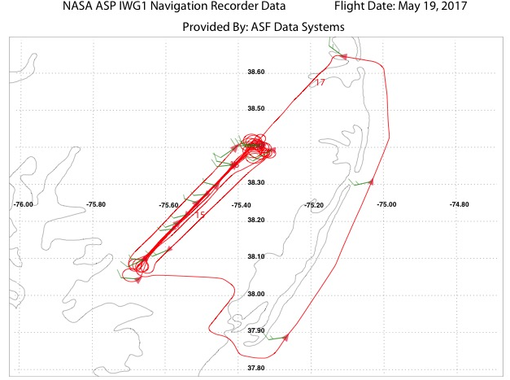

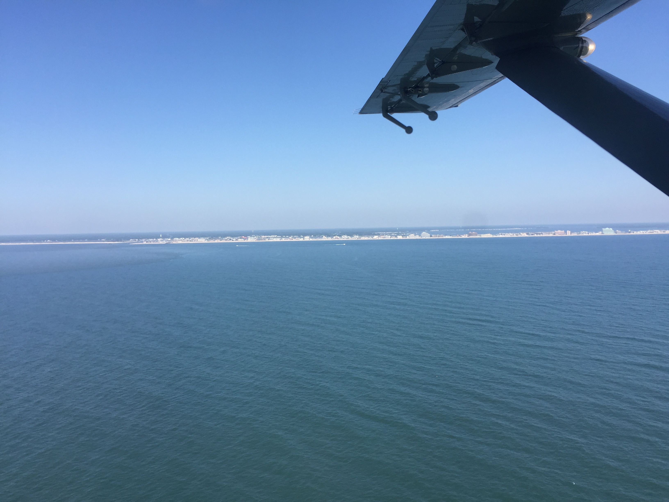
Photo of Ocean City, MD (5/19/2017 taken at 1420 UT).

CARAFE-CMS2017 Science Flight Report for 2017-05-26

Science Flight #9: Alligator River
Pilots: R. Rogers, A. Barringer
Science Crew: P. Newman, L. Barry, J. Digangi, R. Hannun, videographer
Reporting: P. Newman

Objectives: Measure GHG, water, and heat fluxes over coastal plain wetland forests in North Carolina at Alligator River National Wildlife Refuge. Characterize variations of mean mixing ratios and surface flux with forest type, inundation state, and surface conditions especially in search of CH4 flux. Compare airborne flux distributions with those from Ameriflux/NCSU tower measurements at Alligator River site (one of only a couple sites measuring CH4 flux within range).

http://ameriflux-data.lbl.gov:8080/SitePages/siteInfo.aspx?US-NC4

Summary:

The week of May 22-26 was generally poor WX-wise, but the forecast for May 26 appeared very good. Hence, the download was postponed to the following week instead of May 26, and a repeat flight was planned to the Alligator River National Wildlife Refuge and Navy Dare Bombing range situated between Albemarle Sound to the north and Pamlico Sound to the south.

The flight was planned for 9AM-1PM EDT: 1) in order to avoid predicted afternoon Cb activity, & 2) because of the availability of the range for the 10-11 AM period. Our alternative plan was to fly to the Great Dismal Swamp if we were kicked out of the Dare Range, but fortunately, this did not happen.

Flight start-up was pretty nominal, and takeoff was at 12:52 (8:52 EDT). We initially climbed to about 4900’ and found the boundary layer at about 1700-2200’ near WFF. There was a broken cloud deck over Delmarva at about 5000’, with a scattered cloud layer out to sea. A small boundary layear (residual?) was observed near 4700’. About ½ down the peninsula we dropped to 2500’ and continued at this altitude across the Chesapeake to Norfolk (see Figure 1).

Over Norfolk we turned towards AlligatorN and ascended to about 6700’ (see Figure 2). Skies were very clear when we arrived (See Figure 3).

At 13:43 we arrived over AlligatorN and began a spiral descent down to 500’. On this descent, we saw the boundary layer at about 2900’. Over this region, skies were clear and turbulence was light-moderate (sloshing my coffee cup good, & with numerous bumps that would have spilled it). We drifted somewhat to the east of Alligator line, and at 13:53 we were on the track and passed over the NC4 tower (leg 1). We completed 12 legs (see event times below), with 9 @ 500’, 2 @ 1000’, and a final leg where we did a climbing ascent. Four of the tracks were offset from the Alligator line (2 miles west, 1 mile west, 1 mile east, and 2 miles east). The 4th (10:24) and 10th (11:37) legs were both at 1000’. On the 12th leg flying north from Alligator S, we found the boundary layer at 4700 on ascent, and then did a downward profile to find the boundary layer at 4500’-4600’ on descent near the northern end of the Alligator line (still over land). A distinct boundary layer (hazy) was apparent on climb-out over the Alligator line, with a few clouds formed above the boundary layer.

Shortly before 11 AM EDT, we found that scheduled use of the bombing range for the 11-12 period had been cancelled. Hence, we were able to spend 2h on the Alligator track instead of only one hour.

Transit back to WFF was nominal, with wind maneuvers on the return track at ~2500’. Landing at 16:55:41 with normal turn off routines.

Rawinsonde special sounding at 18Z flown from WFF.

Instruments:
LGR/Picarro/PAR – All ran normally. CH4/H2O in fast flux mode.

N2O/CO ran normally (slow mode) on low legs. In-flight cal system exercised a few times.

DLH – Got good data throughout.

BFVNI – Visible, FLIR, and multispectral (Micasense) cameras acquired images normally.

TAMMS – Good data throughout. Applanix data looks normal. Honeywell pressure transducers that were giving problems were replaced/reprogrammed on 5/24 and operated well in flight.

NASDAT – good.

Event Times (UT approximate):
12:39 Engine start
12:41 Power switch, dewpoint on
12:45 Taxi
12:51:49 Takeoff
12:53 Boundary layer top at 1700-2200’
13:00 Ascended to about 4900’ en route towards Norfolk
13:02 Descended to 2700’ on route to Alligator
13:17 Turned toward Alligator River while passing near Norfolk, ascended to 6700’
13:43 Began spiral descent near AlligatorN to 500’
13:53 Leg 1: Joined track at NC4 near NC4 and proceeded S at 500’
14:02 Leg 2: AlligatorSAlligatorN @ 500’
14:12 Leg 3: AlligatorNAlligatorS @ 500’, offset 2mi. W of track
14:24 Leg 4: AlligatorSAlligatorN @ 1000’
14:37 Leg 5: AlligatorNAlligatorS @ 500’, offset 1mi. W of track
14:49 Leg 6: AlligatorSAlligatorN @ 500’
15:01 Leg 7: AlligatorNAlligatorS @ 500’, offset 1mi. E of track
15:13 Leg 8: AlligatorSAlligatorN @ 500’, offset 2mi. E of track
15:25 Leg 9: AlligatorNAlligatorS @ 500’
15:37 Leg 10: AlligatorSAlligatorN @ 1000’
15:48 Leg 11: AlligatorNAlligatorS @ 500’
16:00 Leg 12: AlligatorNAlligatorS, climbing on track to 5000’
16:06 max alt. of 5000’, began descent down to 2500’, Bndry at 4700’ on ascent
16:10 Speed variation maneuvers at 120, 130, 140, 150 kts, ~2500’
16:20 Pitch maneuvers
16:21 Yaw maneuvers
16:55:41 Landing
16:58 Stop Taxi
17:00 Power switch, engines off
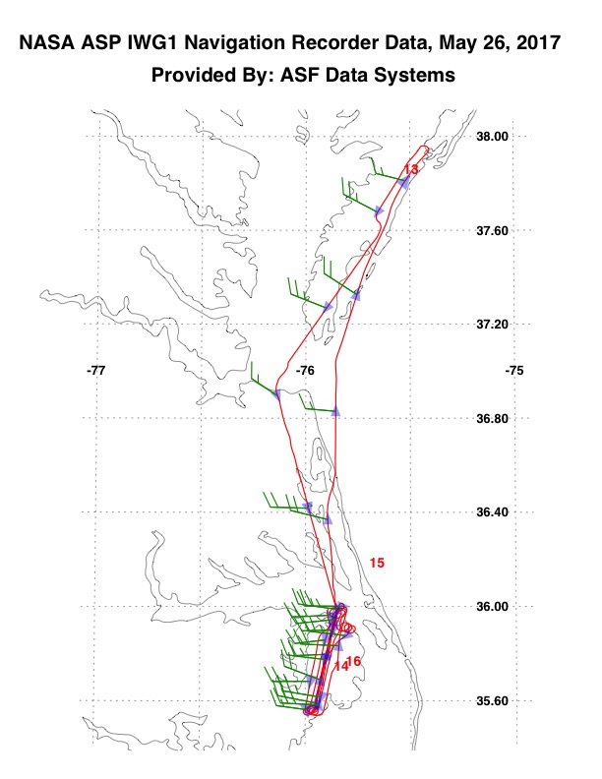
Figure 1. Horizontal Flight profile for 2017-05-26
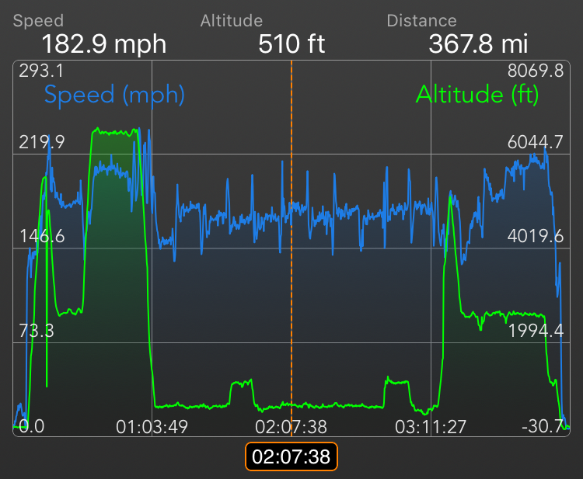
Figure 2. Vertical flight profile (green) and ground speed (blue). Times are durations from turn on. Zero (lhs) is actually 8:45 AM EDT (12:45 UTC), 1:03:49 is

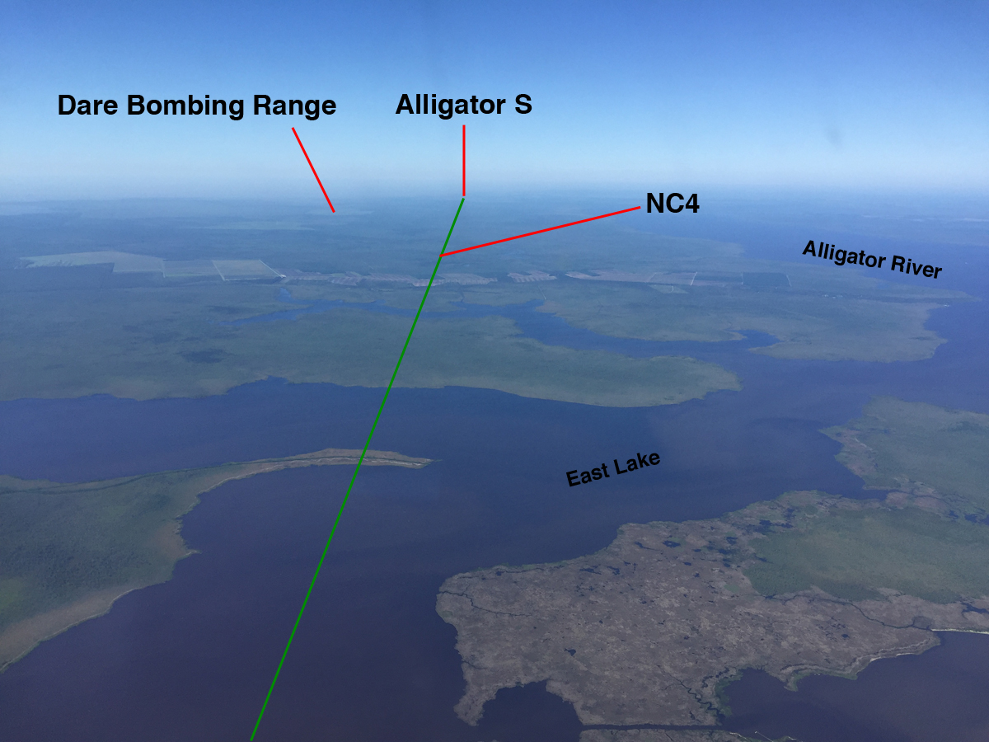
Figure 3. Alligator River track (green line) with approximate locations of NC4 and Alligator S waypoints. Photo taken at 9:40 AM EDT from an altitude of about 6700’ looking south from over Albemarle Sound (35.9934N, 75.8632W).

